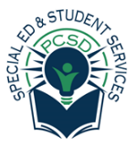



Parent Mentor Trainings FY2022-2023
Date | Topic | Time | Location | Target school | Partners
October 17th | “Make and Take” | 6:00 pm | DWIC  UDL Lab | AU classrooms K-2 | Jessica Mills
October 19th | “Make and Take” | 10:00 am | DWIC  UDL Lab | AU classrooms K-2 | Jessica Mills
October 25th | “Make and Take” | 10:00 am | DWIC  UDL Lab | AU classrooms K-2 | Amanda Inman and Cecile Bolton
October 27th | “Make and Take” | 6:00 pm | DWIC  UDL Lab | AU classrooms K-2 | Amanda Inman and Cecile Bolton
Nov. 15th, 2022 | Self-Regulation for young children with Autism | 11 am  6 pm | BOE – Training room | AU classrooms K-2 | Behavioral Team and School Psychologist -Bolling

Parent Mentor Collaborative Events
Date | Topic | Time | Location | Target parents | Partner
TBD –  1 each month | Parent Ambassador Committee | - | - | All Paulding School Parents | Kim Williams, Karen Woodlief, Michele Craig, Yesenia Lopez
February 16^{th,} 2023 | Special Needs  “Community Resource Fair” | 6:00-7:30pm | Paulding Senior Center | All Paulding School Parents | Yesenia Lopez, Dee Dickson, Angelina Snider, AT Team

Monthly mass emails are sent to parents with Student Services Newsletter. Information about events and resources is provided by:
- Transition Specialist
- Parent Mentor
- Behavior Team
- Assistive Technology

Let us know what trainings you would like the Parent Mentor to organize:
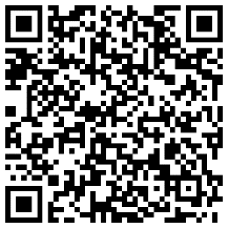
https://forms.office.com/Pages/ResponsePage.aspx?id=6xNNCmZacEqS8TktbtujqqgumMlqIdpHjIpxlgpa0SFUQkxSRDhKQjRDRzUyRVlGS0dZTUxBUzRPNC4u

